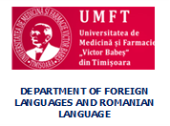
The 5th edition of the workshop
COMMUNICATION SKILLS – A PRACTICAL APPROACH FOR STUDENTS
Timișoara, 22 November 2019

Please complete the registration form and send it to one of the addresses by November 8th, 2019:
frinculescu.iulia@umft.ro
or
nicosim_adi@yahoo.com

REGISTRATION FORM

Surname:
First name:
Specialization/Major in:
Year of study:
E-mail address:
Title of the presentation:
Title of the poster:

