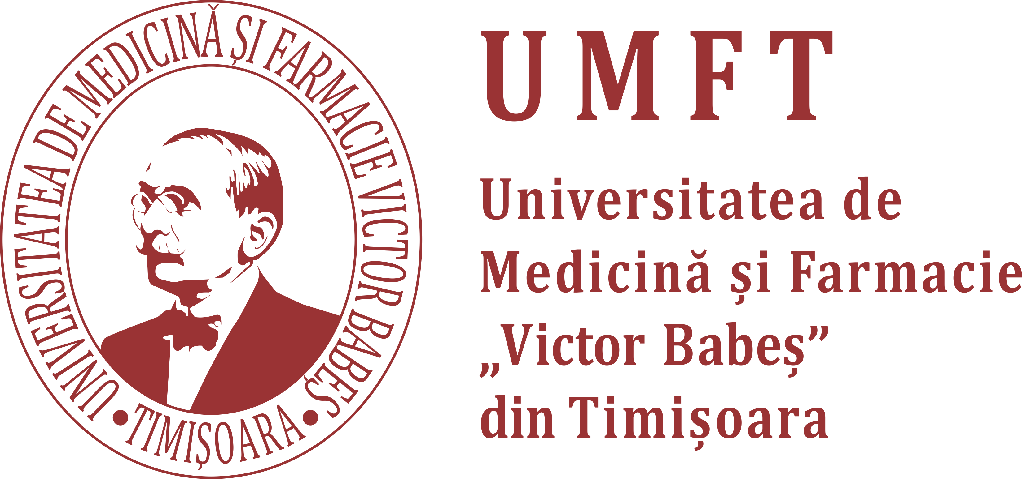
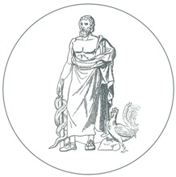ACADEMIA DE ȘTIINȚE MEDICALE, FilialaTimișoara

Sesiunea ştiinţifica a Şcolilor Doctorale UMF Timişoara
Medicină-Farmacie şi Medicină Dentară
şi a Academiei de Ştiinţe Medicale
Sesiunea I
8.30 – 9.00 Sesiune postere
Prezidiu: Prof. univ. dr. Sporea Ioan, Prof. univ. dr. Sinescu Cosmin

9.00-9.15 Gabor Alin Gabriel
ADHESION OF SCAFFOLDS WITH IMPLANTS TO THE MANDIBULAR BONE WITH A DEFECT
9.15-9.30 Hajaj Tareq
DETERMINING THE BIOLOGICAL SEALING QUALITY OF THE IMPLANT-ABUTMENT INTERFACE USING STREPTOCOCCUS MUTANS IN BOTH CONICAL AND INTERNAL HEX CONNECTIONS

9.30-9.45 Drăghici George Andrei
SHORT-TERM EFFECTS OF VERY LOW DOSE CADMIUM FEEDING ON COPPER, MANGANESE AND IRON HOMEOSTASIS: A GASTROPOD PERSPECTIVE

9.45-10.00 Mardare Mihai
SPINAL GROWTH IN CHILDREN WITH EARLY ONSET SCOLIOSIS TREATED WITH TAIL-GATING TECHNIQUE FOR MAGNETICALLY CONTROLLED GROWING RODS

10.00 – 10.30 Sesiune postere
Sesiunea II
Prezidiu: Prof. univ. dr. Şerban Margit, Prof. univ. dr. Mihalaş Gheorghe

10.30-10.50 Prof. Univ. dr. MIHALAŞ GHEORGHE
USE AND MISUSE OF BIOSTATISTICS IN MEDICAL RESEARCH

10.50-11.05 Pop David
NEBIVOLOL EFFECT ON DOXORUBICIN-INDUCED CARDIOTOXICITY
IN BREAST CANCER
11.05-11.20 Morariu Vlad
SYNTHESIS AND CHARACTERIZATION OF A POLYURETHANE CARRIER USED FOR A PROLONGED TRANSMEMBRANE TRANSFER OF A CHILI PEPPER

11.20-11.35 Dumitrescu Andreea Simina
PRELIMINARY DATA OF FAMILIAL HYPERCHOLOSTEROLEMIA (Fh) PATIENTS
IN ROMANIA

11.35 -11.50 Prof. univ. dr. Sporea Ioan
CUVÂNT DE ÎNCHEIERE

